Name:
Motion, Forces and Energy Test
Score: / 55

Instructions to students:
Time limit: 55 minutes.
Complete all questions on this paper.
Answer all numerical questions to 3 significant figures. (max. 1 mark penalty)
Use of scientific calculators (supplied by students) and 2014 Physics formula sheet (supplied by teacher) permitted.

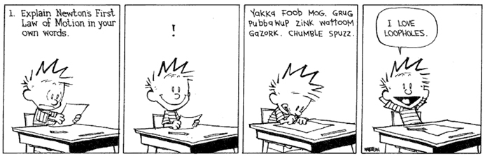

- A rider & bicycle has a combined mass of 45∙6 kg which has a change of speed from 2.85 ms⁻¹ to 4.912 ms⁻¹. Calculate and state the gain or loss in kinetic energy. [3]

- An electric motor uses 2400 J of electrical energy in 2 minutes.
Calculate the power rating of the motor. [2]

- Wendy has decided to try and an experiment her awesome physics teacher suggested. She takes her bathroom scales into a lift. Before the lift moves the scales show her mass to be 58 kg. What will the scales show her mass to be if the lift accelerates downwards at 2 ms⁻²? [3]

- Draw a labelled Free Body Diagram to represent the forces on a box at rest on an inclined plane: [3]

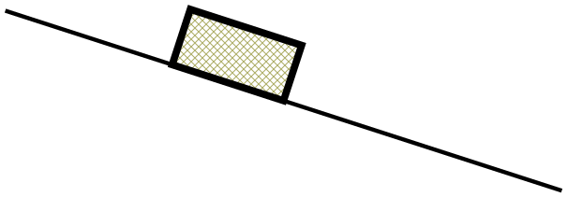

- A car of mass 500 kg travelling west at 25 ms⁻¹ crashes into the rear of a stationary truck with a mass of 6000 kg. The vehicles lock together on impact. [7 marks]

  - What is the total kinetic energy of the system before the collision? [2]

  - What is the velocity of the car and truck immediately after the collision? [2]

  - What is the total kinetic energy of the system after the collision? [2]

  - Is this an elastic or inelastic collision? Explain [1]

- Parents of young children buy a swing set for their children. The 2·4 kg swing is held by two ropes and rests 0·85 m above the ground. [11 marks]

  - Draw a free body diagram showing all forces when the swing is at rest. [2]

  - What is the tension in each of the two ropes when the swing is empty? [2]

An older child whose mass is 35 kg sits on the swing. The mass of the child is too great for the swing and both ropes break.

  - What was the combined potential energy of the swing and child when the ropes broke? [2]

  - How long does it take the child to fall to the ground? [2]

  - ‘Softfall’ is a rubber substance used on the ground of playgrounds. Explain using physics principles why a child is less likely to be injured if they fall onto ‘Softfall’ compared to concrete: [3]

- A model rocket with a mass of 600 g exerts takes off vertically with a thrust of 80 N. It takes 0∙45 s for all its fuel to burn. [8 marks]

  - Neglecting air resistance, draw a diagram showing all forces on the rocket in flight and calculate the net force on the rocket: [2]

  - What is the net acceleration of the rocket? [2]

  - What is the height of the rocket when the rocket fuel runs out? [2]

  - What work is done on the rocket in the first 0.45 s? [2]

- Declan is practising throwing balls. He throws a 150 g rubber ball with a velocity of 4∙2 ms⁻¹ at a basketball sitting on the ground. The basketball has a mass of 620 g and rolls away with a velocity of 1∙45 ms⁻¹. What is the velocity of the rubber ball after hitting the basketball? [4]

- A boy riding a skateboard on a footpath has a mass of 35∙8 kg with a velocity of 14∙45 ms⁻¹ when he crosses over to a section of grass. The grass provides a retarding force of 50 N for 2∙5 s against his motion, before he returns to the footpath. What is the velocity of the boy when he returns to the footpath? [3]

- In Australia drivers and passengers in cars are required to wear seatbelts. By naming and using physics principals explain why not wearing a seatbelt during a collision is unsafe. [3]

- On a recent visit to Adventure World John decides to go down the ‘Giant” water slide. He and his rubber matt have a combined mass of 78∙9 kg. John is at rest at point A and allows gravity to accelerate him down the slide. [8 marks]

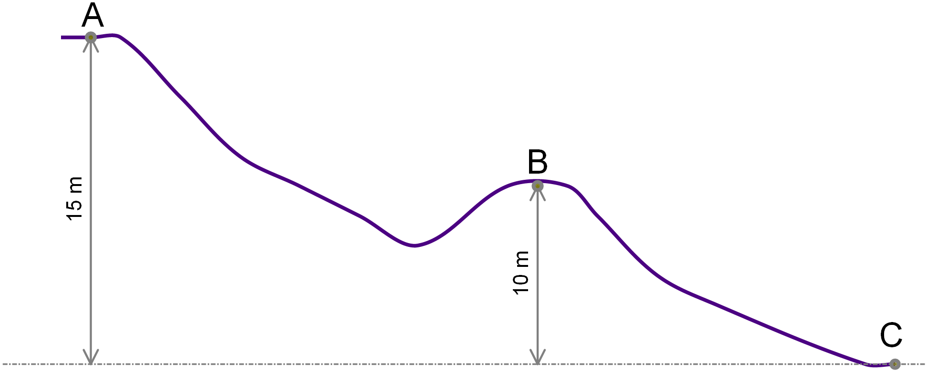

  - Calculate the velocity of John when he reaches point B assuming no loss of energy to friction: [3]

  - As John passes point B he panics and tries to use his feet to slow himself down so that he loses 5% of his mechanical energy between point B and C. What is John’s velocity at point C? [2]

  - After several complaints about safety it was decided to add a ‘slow down zone’ at the end of the slide. What retardation force must this zone provide so that of John comes to rest in no less that 1∙6 s? (if you were unable to calculate a velocity above use v = 20 ms⁻¹) [3]

END OF TEST

THIS PAGE LEFT INTENTIONALLY BLANK

